Study of 8086 Microprocessor Architecture

- Architecture:
The Intel 8086 is a 16-bit microprocessor introduced by Intel in 1978. It is the foundation of the x86 family of processors and was designed to execute complex instructions efficiently.

Main Features:
- 16-bit processor with 20-bit address bus → can access 1 MB memory (2²⁰ bytes)
- Has segmented memory architecture
- Contains Arithmetic Logic Unit (ALU) for arithmetic and logical operations
- 14 registers (general, segment, and pointer/index)
- Clock speed typically between 5–10 MHz
- Supports multiprogramming and pipelining (instruction queue)
Block Diagram:

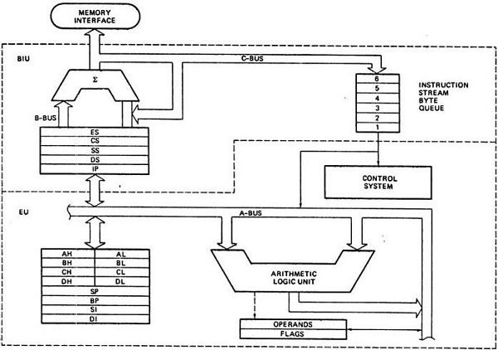

How it works:
- The BIU fetches the next instruction while EU executes the current one — providing pipelined execution.
- This improves performance by overlapping fetch and execute cycles
- Register Organization:

8086 has several types of registers categorized as:

- General Purpose Registers (GPR):
Register | Purpose | Description
AX | Accumulator | Used in arithmetic, logic, and data transfer
BX | Base Register | Used in indexed addressing
CX | Count Register | Used in loops and shifts
DX | Data Register | Used in multiplication/division and I/O operations

- Segment Registers:
Register | Purpose
CS | Code Segment – holds program code
DS | Data Segment – holds variables/data
SS | Stack Segment – manages stack operations
ES | Extra Segment – used for string operations

- Pointer and Index Registers:
Register | Purpose
SP | Stack Pointer
BP | Base Pointer
SI | Source Index
DI | Destination Index
IP | Instruction Pointer (points to next instruction)

- Flag Register:
  - Contains status flags (like Carry, Zero, Sign, Overflow) and control flags.
  - Used to indicate the outcome of operations.

- Memory Segmentation in 8086:

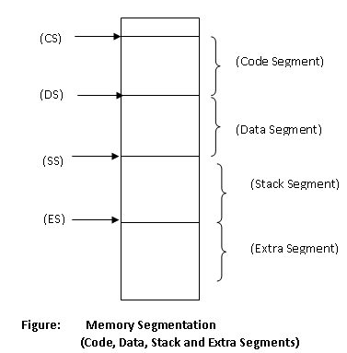
The 8086 uses a segmented memory model to efficiently access its 1 MB address space. Memory is divided into four main segments:
- Code Segment: Contains executable program instructions.
- Data Segment: Holds variables, data, and constants.
- Stack Segment: Stores temporary data, return addresses, and handles function calls.
- Extra Segment: Used for additional data and string operations.
Each segment is 64 KB in size. The physical memory address is calculated using both the segment and offset addresses with the formula:
Physical Address = (Segment × 10H) + Offset
For example, if CS = 2000H and IP = 1234H, then the physical address = 2000H × 10H + 1234H = 21234H.

- Example Programs (Assembly Language)

  - Hello World Program

Code:
section .data
msg db "Hello world!", 0ah

section .text
global _start

_start:
mov rax, 1
mov rdi, 1
mov rsi, msg
mov rdx, 13
syscall
mov rax, 60
mov rdi, 0
syscall
Output:
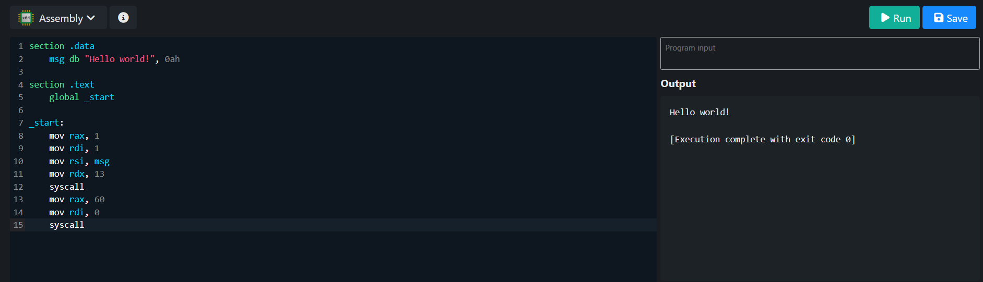

  - Addition of Two Number

Code:
section .data
num1 db 3
num2 db 5
result db 0

section .text
global _start

_start:
mov al, [num1]
add al, [num2]
add al, '0'
mov [result], al

mov rax, 1
mov rdi, 1
mov rsi, result
mov rdx, 1
syscall

mov rax, 60
xor rdi, rdi
syscall

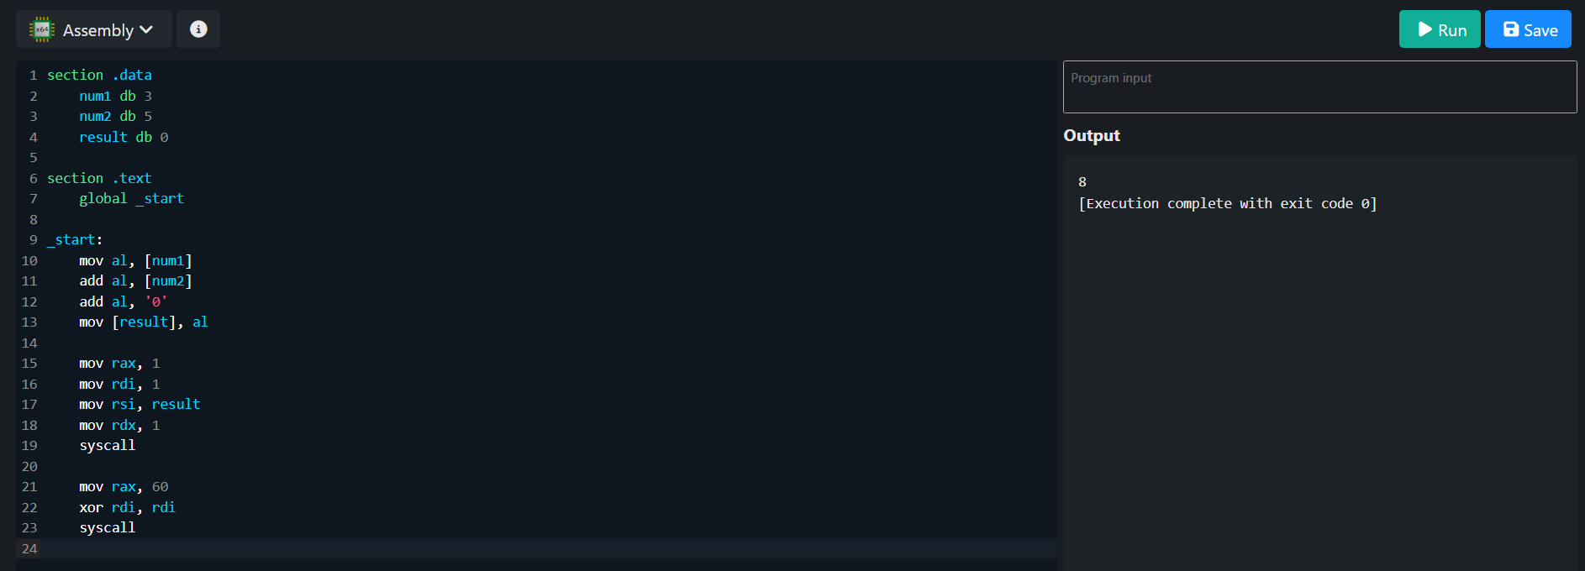
Output:

